Table of Contents

1 Dorian Administration 3
1.1 Java SDK 3
1.2 MySQL 4.1.x 3
1.3 Ant 1.6.2 3
1.4 Globus 4.0.2 3
1.5 Tomcat 5.0.30 (Only required if deploying to Tomcat) 3
1.6 Certificates and Security Descriptor 5
1.7 Obtain and Build Dorian 6
1.8 Choosing a Deployment Option 7
1.9 Testing 9
1.10 Server Installation Complete 9
2 Dorian Portal 10
2.1 Pre-Installation 10
2.2 Configuration 11
2.3 Building Process 11
2.4 Usage 12

Dorian Administration
Pre-Installation

Dorian is dependent on several software packages/systems that must be installed prior to installing Dorian. The following sections will let you know which software you need to download and install in order to run Dorian.

Java SDK

Dorian is written in Java therefore it requires the Java SDK. Some of the other software components Dorian uses require specific versions of the Java SDK. Taking this into consideration Dorian requires jsdk1.5 or higher. After installing you will have to set up an environmental variable pointing to the Java SDK directory and name it JAVA_HOME. Then, include the JAVA_HOME/bin directory in the PATH.

MySQL 4.1.x

For persisting user accounts and other information, Dorian uses the MySQL database. MySQL can be downloaded from http://www.MySQL.com/products/MySQL/.

Download and install MySQL 4.1.x.
NOTE:
Make a root privileged user and note the username and password for later use in this installation guide.

Ant 1.6.2

The Dorian service along with the Globus Toolkit in which Dorian is built on, uses Jakarta Ant for building and deploying. Dorian requires Ant version 1.6.2. Ant can be downloaded from http://jakarta.apache.org/ant. After downloading and installing Ant you will need to set up an environmental variable pointing to the Ant directory and name it ANT_HOME. Then, include the ANT_HOME/bin directory in the PATH.

Globus 4.0.2

Dorian is built on top of the Globus Toolkit version 4.0.2. Dorian requires a ws-core installation of the Globus Toolkit 4.0.2. Please consult the Globus installation guide for more details (http://www.globus.org/toolkit/docs/4.0/admin/docbook/index.html). The following configuration will ensure that Globus will work correctly with Dorian.

Configuration:

Download and install Globus 4.0.2 to a local directory. Then, set up an environmental variable pointing to the Globus directory and name it GLOBUS_LOCATION. Make sure to include the GLOBUS_LOCATION/bin directory in the PATH.

Tomcat 5.0.30 (Only required if deploying to Tomcat)

Dorian is optionally deployed as a Grid Service to a Tomcat deployed Globus Toolkit. We recommend Tomcat version 5.0.30. Tomcat can be downloaded from
http://jakarta.apache.org/tomcat. The following configuration will ensure that Tomcat will work correctly with Dorian.

Configuration:

Download and install Tomcat 5.0.30. Then, set up an environmental variable pointing to the Tomcat 5.0.30 directory and name it CATALINA_HOME. Make sure to include the CATALINA_HOME/bin directory in the PATH. Now we are going to setup Tomcat to run securely. For the following steps you will be editing the <tomcat_root>/conf/server.xml configuration file.
  - Add a HTTPS Connector in the <Service name="Catalina"> section and update the parameters appropriately with your local configuration:
<Connector
className="org.globus.tomcat.coyote.net.HTTPSConnector"
port="8443" maxThreads="150" minSpareThreads="25" maxSpareThreads="75"
autoFlush="true"
disableUploadTimeout="true" scheme="https"
enableLookups="true" acceptCount="10" debug="0"
proxy="/path/to/proxy/file"
cert="/path/to/certificate/file"
key="/path/to/private/key/file"
cacertdir="/path/to/ca/certificates/directory"/>
In the above the proxy, cert, key and cacertdir attributes are optional. Furthermore, the proxy and the combination of cert and key attributes are mutually exclusive.
  - Add a HTTPS Valve in the <Engine name="Catalina" ... > section:
<Valve className="org.globus.tomcat.coyote.valves.HTTPSValve"/>
Also, you may have to edit <tomcat.dir>/webapps/wsrf/WEB-INF/web.xml if you are running Tomcat on a non-default port, i.e. not using port 8443 (HTTPS). For example, if you run Tomcat on port 443 using HTTPS then the WSRF servlet entry should be modified as follows:
<web-app>
...
<servlet>
<servlet-name>WSRFServlet</servlet-name>
<display-name>WSRF Container Servlet</display-name>
<servlet-class>
org.globus.wsrf.container.AxisServlet
</servlet-class>
<init-param>
<param-name>defaultProtocol</param-name>
<param-value>https</param-value>
</init-param>
<init-param>
<param-name>defaultPort</param-name>
<param-value>443</param-value>
</init-param>
<load-on-startup>true</load-on-startup>
</servlet>
...
</web-app>

Certificates and Security Descriptor

Dorian runs as a secure service through Globus. For Globus to run as a secure container there are multiple certificates that Globus must trust. The following instructions will guide you through this configuration process:

1. Create a Directory for Globus Configuration Files

On Windows, create a directory called “.globus” and put it in your “Documents and Settings\User Name” directory. You may need to use the Windows command line to create this directory, as Windows typically doesn’t allow users to create files or directories whose names begin with a dot: Start ->Run ->type “cmd” in the text field and click OK:

> cd C:\Documents/ and/ Settings\YourUserName\ (if you’re not
already there)
> mkdir .globus
On Linux, on the command line:
$ cd /home/YourUserName
$ mkdir .globus

2. Obtain a Certificate Authority (CA) Certificate and the Dorian CA Certificate

Contact an administrator in your department/unit and obtain the Certificate Authority certificate and the Dorian CA certificate for the Dorian server you will be using. You will receive two files with .pem extensions. These certificates are plain text files used by Dorian and Globus verifying the authenticity of the authority. Dorian and Globus need to be able to locate the files in order to encrypt and authenticate your connections to grid services and to generate grid proxies that will be used to establish secure and authenticated connections on your behalf between your programs and grid services and between the various intermediate grid services themselves.

3. Create a Certificates Directory

Dorian and Globus will look in a specific place to try to locate CA certificates. Create a sub-directory of the .globus directory and call it certificates. Copy your CA certificate(s) and Dorian CA certificate in this directory, renaming each certificate to have a .digit extension. For example, if your CA certificate was named cacert.pem, rename it to cacert.1. Name the Dorian CA in a similar fashion. Note, each certificate in this directory must have a different .digit extension.

4. Create a Host Credentials Directory and Obtain Host Credentials

Dorian and Globus will look in a specific place to try and locate host credentials. Create a local directory where you will place your host credentials. To obtain host credentials contact your administrator. Place the host certificate and host key in the directory you just created.

5. Configure the Security Descriptor

You can find a template for the security descriptor file in the resources folder in the Dorian directory. Copy this template into a local directory, preferably in the same location as the host credentials. Then edit the security descriptor to point to the host certificate and host key obtained in the previous step. The security descriptor should be similar to Figure 1.6.1 below.

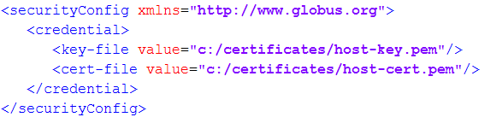
Figure 1.6.1 Security Descriptor

Obtain and Build Dorian

Caution!
The installation of Dorian requires the previous sections to all be completed.
Here is a checklist of all prerequisites that need to be met:
- Java 4.4.02
- MySQL 4.1.x
- Ant 1.6.2
- Configuration of certificates and security descriptor.

Build Dorian:

Given that you have obtained and installed the required software packages, and set the required environment variables; you are ready to build Dorian. This can be done by typing ant clean all into the Dorian directory. After Dorian is built there are some configuration settings that need to be done. The following will guide you through this process:

Configuration:

There is one configuration file that needs edited in order for Dorian to work on your machine. First, go to the ‘etc’ folder in the Dorian directory. You will need to edit the file named “dorian-conf.xml”. In the Database section, set the username and password to match the username and password you created for MySQL in section 1.2. Refer to the dorian-conf.xml file in Figure 1.4.1 below.

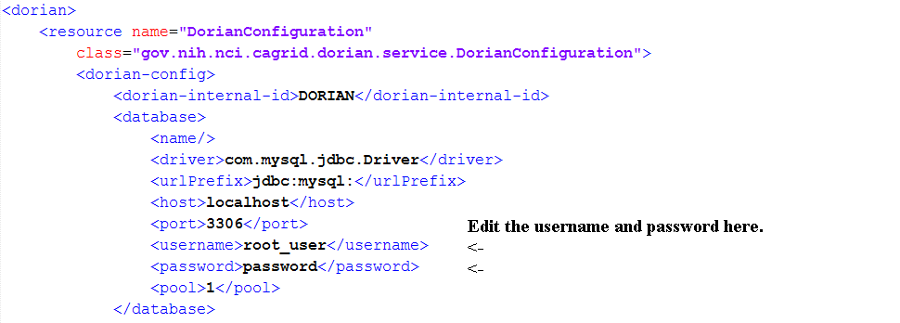
Figure 1.7.1 dorian-conf.xml

Choosing a Deployment Option

Now that you are done building Dorian there are two options for deploying Dorian to a secure container. The two options that Dorian supports are deploying to Globus or deploying to Tomcat. If you choose to deploy Dorian to Tomcat, then you must complete the Tomcat installation section. The following two parts of this section will explain the steps to deploy for each option.

Deploy to Globus
The following are instructions on how to deploy Dorian to a secure Globus container.

Run ant deploy from the Dorian directory. This command will deploy Dorian to Globus. Go to the Globus directory (GLOBUS_LOCATION) in your command prompt. Type “bin\globus-start-container –containerDesc location/of/security-descriptor.xml”. Replace “location/of/security-descriptor.xml” with the path where you saved the security descriptor. This command will stand up a secure Globus container. A secure Globus container should be running and deployment is complete. The container should resemble and contain the highlighted item in Figure 1.7.1 below. Make sure the Dorian service is deployed before proceeding.

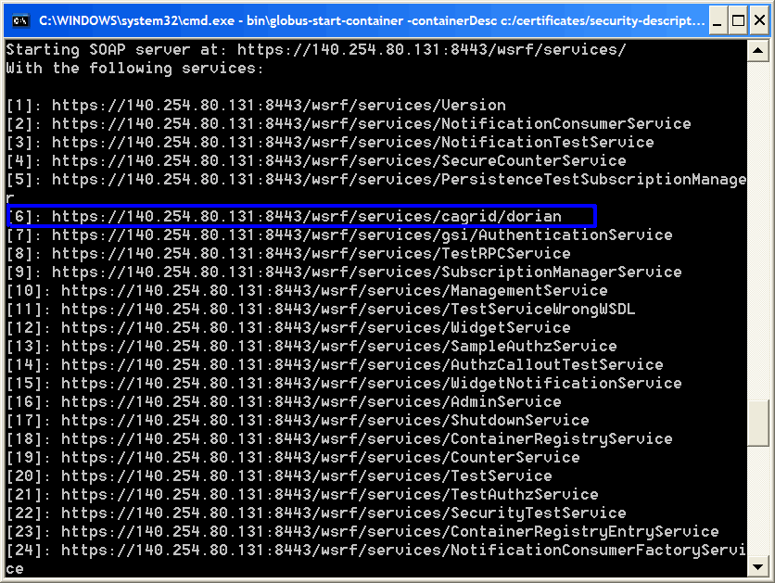
Figure 1.8.1

Deploy to Tomcat (Complete Section 1.8 before proceeding)

The following are instructions on how to deploy Dorian to a secure Tomcat container.

Go to the Globus directory in the command prompt. We will now run a command to deploy a secure Tomcat container. Run this command →

ant -f share/globus_wsrf_common/tomcat/tomcat.xml deploySecureTomcat -Dtomcat.dir=/path/to/Tomcat

“path/to/Tomcat” is the local directory where Tomcat is installed.

Run ant deploy from the Dorian directory. This command will deploy Dorian to Tomcat. Before we can startup the Tomcat container, we need to copy 2 endorsed files from the Dorian Project to Tomcat. Copy xercesImpl.jar and xml-apis.jar from the “DorianLocation/ext/endorsed/lib” directory to the “CATALINA_HOME/common/endorsed” directory. Then, go to CATALINA_HOME\bin (i.e., the bin folder where Tomcat is installed) in the command prompt. Run ‘startup’. The terminal will display something similar to this →

Jan 19, 2006 4:28:05 PM org.apache.catalina.startup.Catalina start
INFO: Server startup in 28375 ms

Testing

To test Dorian, run the portal by typing ant dorianPortal from the Dorian directory. Then, click Identity Federation from the portal toolbar. From the Identity Federation Menu, select Create Proxy and click Select. In the User Id and Password dialog box, for User Id, enter dorian and for the password enter password. Click Authenticate. Upon success, you should see a screen similar to Figure 1.9.1:

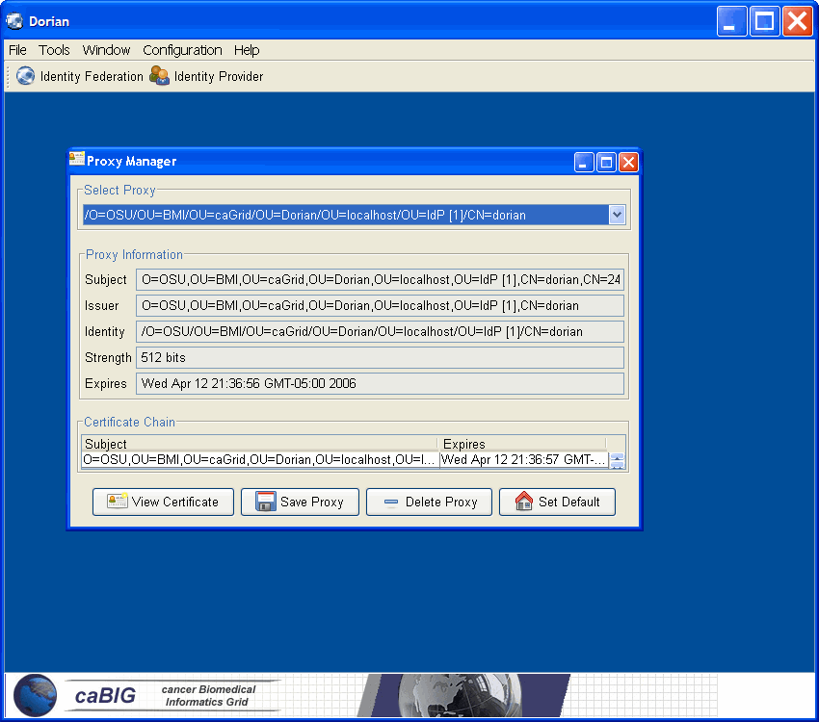
Figure 1.9.1

Server Installation Complete

At this point you have successfully setup and deployed Dorian.

2 Dorian Portal
Dorian provides a simple, user-friendly way for people who want to use services on a grid to apply for and register accounts on that grid and receive and use credentials that can provide guaranteed, secure, authenticated, and authorized grid communications. It also allows grid administrators to review users’ registration applications, approve or reject those applications, and other ways set up and manage grid user accounts. To use services on a grid on which there is limited and/or tightly controlled access—such as caBIG—there needs to be a reliable and straightforward way for services to identify users (or other services) initiating requests. Additionally, the grid services may need to encrypt communications to ensure privacy and will need to have means for guaranteeing that the requesting user (or service) is who he says he is, a way of guaranteeing the user’s authenticity. There also needs to be a way to make sure that the message the user (or service) sent is identical to the message was received, a way to guarantee message integrity.

2.1 Pre-Installation

The Dorian Portal is dependent on several software packages/systems that must be installed prior to using the Dorian Portal. This section will let you know which software you need to download and install in order to run the Dorian Portal.

Java SDK

Dorian is written in Java therefore it requires the Java SDK. Some of the other software components Dorian uses require specific versions of the Java SDK. Taking this into consideration Dorian requires jsdk1.4.2_04 or higher. After installing you will have to set up an environmental variable pointing to the Java SDK directory and name it JAVA_HOME. Then, include the JAVA_HOME/bin directory in the PATH.

Ant

The Dorian service along with the Globus Toolkit in which Dorian is built on, uses Jakarta Ant for building and deploying. Dorian requires Ant version 1.6.2. Ant can be downloaded from http://jakarta.apache.org/ant. After downloading and installing Ant you will need to set up an environmental variable pointing to the Ant directory and name it ANT_HOME. Then, include the ANT_HOME/bin directory in the PATH.

Globus Toolkit

Dorian is built on top of the Globus Toolkit version 4.0.2. Dorian requires a ws-core installation of the Globus Toolkit 4.0.2. Please consult the Globus installation guide for more details (http://www.globus.org/toolkit/docs/4.0/admin/docbook/index.html). The following configuration will ensure that Globus will work correctly with Dorian.

Configuration:

Download and install Globus 4.0.2 to a local directory. Then, set up an environmental variable pointing to the Globus directory and name it GLOBUS_LOCATION. Make sure to include the GLOBUS_LOCATION/bin directory in the PATH.

2.2 Configuration

Since Dorian runs securely, there are certificates you need in order to run Dorian Portal. You will need to acquire the Dorian CA certificate and any other trusted Certificate Authorities your department/unit requires. The following steps will assist you in this process:

1. Create a Directory for Globus Configuration Files

On Windows, create a directory called “.globus” and put it in your “Documents and Settings\User Name” directory. You may need to use the Windows command line to create this directory, as Windows typically doesn’t allow users to create files or directories whose names begin with a dot: Start ->Run ->type “cmd” in the text field and click OK:

> cd C:\Documents/ and/ Settings\YourUserName\ (if you’re not
already there)
> mkdir .globus
On Linux, on the command line:
$ cd /home/YourUserName
$ mkdir .globus

2. Obtain the Dorian CA Certificate and other CA certificates

Contact an administrator in your department/unit and obtain the Dorian CA certificate and other CA certificates, if any, for the Dorian Portal you will be using. You will receive a file(s) with a .pem extension. Dorian and Globus need to be able to locate the file(s) in order to encrypt and authenticate your connections to grid services and to generate grid proxies that will be used to establish secure and authenticated connections on your behalf between your programs and grid services and between the various intermediate grid services themselves.

3. Create a Certificates Directory

Dorian and Globus will look in a specific place to try to locate CA certificates. Create a sub-directory of the .globus directory and call it certificates. Copy your Dorian CA certificate in this directory, renaming the certificate to have a .digit extension. For example, if your Dorian CA certificate was named dorianCA.pem, rename it to dorianCA.1. Rename the other trusted CA certificates in a similar fashion with different .digit extensions.

2.3 Building Process

Given that you have obtained and installed the required software packages, and set the required environment variables; you are ready to build the Dorian Portal. This can be done by typing ant clean all into the Dorian directory. At this point the Dorian Portal should be built and you are ready to start using the portal.

2.4 Usage

General users will follow a basic pattern when working with Dorian:

If you are not already registered with an account on the grid:
- Start the client
- Input your user and personal information
- Click to apply for an account
Once you have an account on the grid:
- Start the client
- Create and obtain a session proxy for use on the grid or obtain an already active proxy.

Administrating users will also follow a basic pattern when working with Dorian:
- Start the client
- Create and obtain a session proxy or obtain an already active proxy
- Check to see if account applications are pending
- Approve or deny applications, input or update user account information, and, possibly, set users status on the Dorian server to give or take away administrative privileges

Starting the Dorian Client

At the command line from the Dorian directory, type:

$ ant dorianPortal

This starts an ant build process that will create the Dorian portal GUI on your desktop.

Inputting User Information and Registering the User

Every user of Dorian must have account information registered with the Dorian server before being allowed to generate a proxy. Users need to provide a potential username and a password and a valid email address among other fields. In its default configuration, Dorian also requires certain personal information before it sends an application to the server for processing by the grid administrator. When the portal first displays on your desktop, click Identity Provider from the toolbar or from the Tools drop down menu. From the Identity Provider menu, choose Register and click Select. In the Login information section, choose the service you wish to register with and supply a username and password. Then fill in the fields in the Personal Information section. Figure 2.4.1 shows the Dorian portal framing the form for entering basic account information. In this example we are making a JoeUser account.

Personal Information field set, you must enter:
1. First Name
2. Last Name
3. Organization
4. Address
5. Address2
6. City
7. State
8. Zipcode
9. Country
10. Phone Number
11. A valid email address (used to confirm the creation of your account)

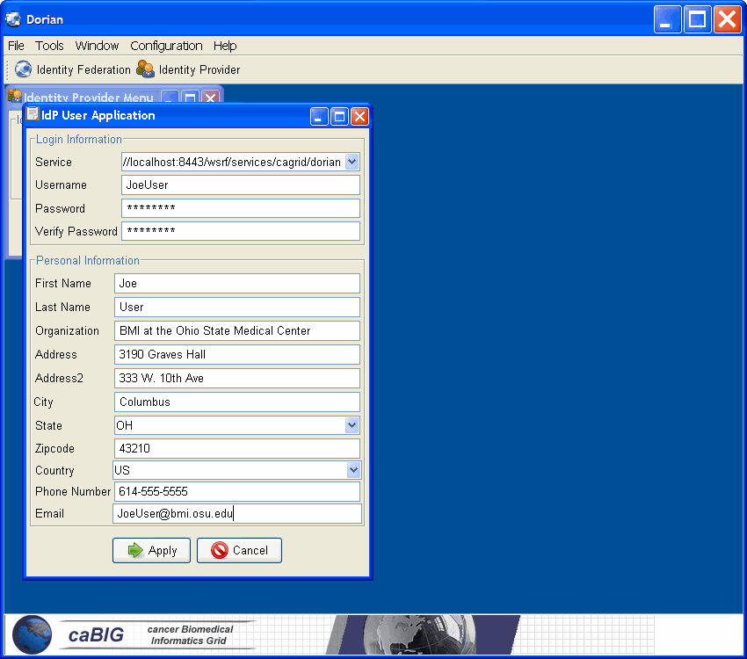
Figure 2.4.1 IdP User Application

Once you have supplied all the required information, Click the Apply button to send your account and personal information to the Dorian server so that an administrator can review your application. When the grid administrator approves your application, the Dorian server will automatically send a welcome email message containing your grid id and the email address of the person who reviewed and approved your application. If for some reason your application was denied, you’ll similarly receive an email notification.

Once your personal and account information has been verified and approved. You can use Dorian to create a proxy for your grid session.

Creating and Managing Credentials (Grid Proxies)

Clicking the Identity Federation menu item in the Dorian portal will bring up a dialogue with a number of radio button options on it. These options allow you to create and manage your grid credentials (your proxy). Before you can do any work on the grid, including using Dorian to administer user accounts, you must create a proxy. To create a proxy, select the Create Proxy radio button and click Select (see Figure 2.4.2). This will bring up the dialogue in Figure 2.4.3. Fill in your username, password, and a time to expire (in hours) for the proxy you are creating. Clicking Authenticate will contact the Dorian server, which will use Globus to generate a grid proxy for your session and return a dialogue with some information about your proxy, including who issued it, who it was issued for (your grid id), the strength of the encryption used in your proxy, and the time remaining before the proxy becomes invalid. See Figure 2.3.4. From the Proxy Manager you also have the ability to view the certificate created, save the proxy to a local directory, delete the proxy and set the proxy as the default proxy Dorian will use for administrative tasks.

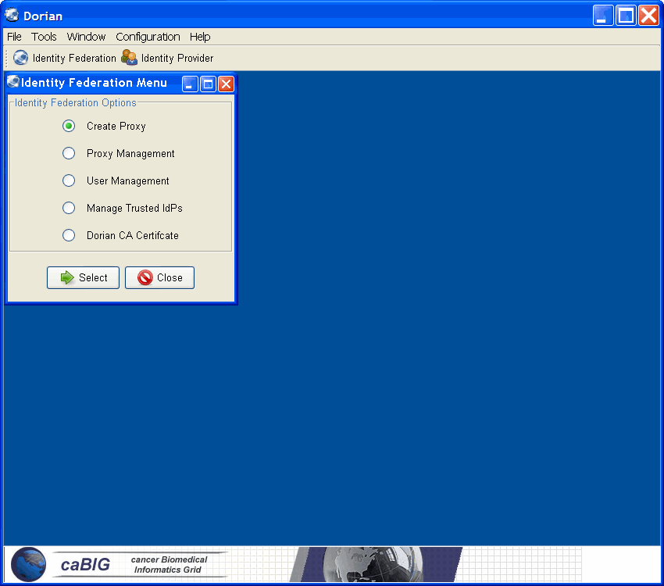
Figure 2.4.2 Identity Federation Menu

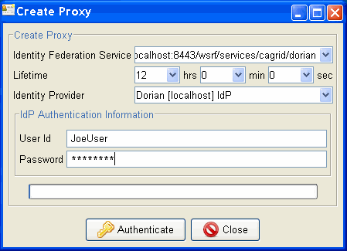
Figure 2.4.3 Create Proxy

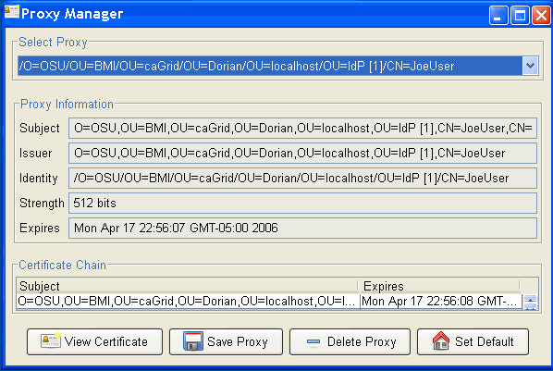
Figure 2.4.4 Proxy Manager

The other radio buttons on the Dorian Identity Federation dialogue allow you manage your certificate or, if you are an administrator, manage other users’ certificates and Trusted IdPs. You have the following options available via the Dorian Identity Federation dialogue:

Create Proxy
Discussed above.

Proxy Management
Gets and locally caches the proxy information for any user who has an active (nonexpired) proxy on the GUMS server. The user will need to know the username and password for any proxy information she wants to retrieve. You must “get” (obtain and cache locally) a proxy before using services on the grid.

User Management
This option allows for administrators to manage or remove Identity Federation users. First, you find users, and then you pick which user to manage or remove. Managing a user allows an admin to set the User Status and User Role for a particular user. The credentials can also be renewed by clicking Renew Credentials at the bottom of the Manage User window.

Manage Trusted IdPs
This allows you to check Add, View/Edit or remove a Trusted IdP.

Dorian CA Certificate
This allows you to view the current Dorian CA Certificate and either import a new one or export the current one to a local directory.

Reviewing, Approving, and Managing Grid Users

Administrative users of Dorian have the ability to review newly submitted applications, approve or deny them, and variously edit user information. Any user of Dorian can bring up the Dorian Manage Users menu (see Figure 2.4.5) by clicking on Dorian Administration in the portal menu. Only users with administrative rights, however, will be able to successfully make changes to user information. General users will need to contact their administrator if they need any part of their accounts updated. When the Dorian server is first brought up on a grid, it has a default administrative user account. This account has total control of user information. On first starting the Dorian client, create a proxy by selecting Create Proxy on the Dorian Identity Federation dialogue and clicking select. In the Create Proxy login dialogue put in the following default administrative information:

Username: dorian
Password: password

Note: To help ensure the security of the system, we recommend that you immediately either create a new user as administrator or make a current user an administrator and then disable the dorian user. See below for instructions about how to change the role of a user.

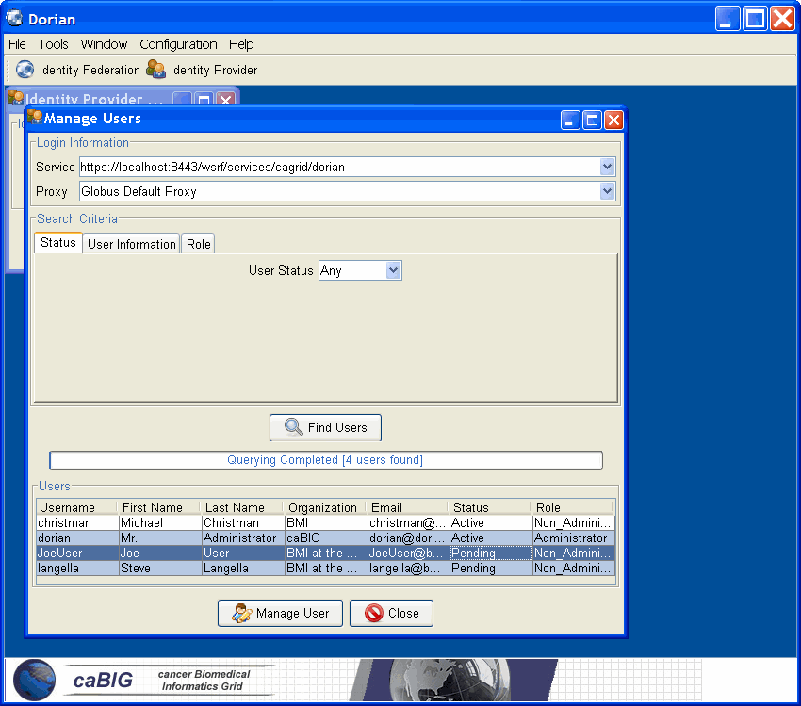
Figure 2.4.5 Manage Users

In the Manage User window select Find Users that will query for users with any given search criteria. Select a user and click Manage User. For our example we will be managing the JoeUser account that we made an application for earlier. This will bring up a screen that allows an administrator to update user information, update account information or change password. An administrator has the ability to set a user’s account to Active or Rejected for pending applications. Also, the administrator can change an account from Active to Suspended. Refer to Figure 2.4.6.

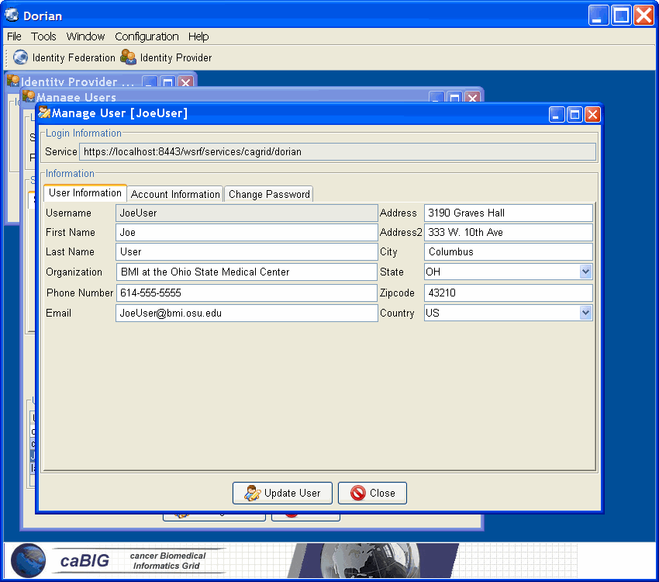
Figure 2.4.6 Manage User

After all the desired updates have been made, click Update User.

Exiting the Dorian Client

When you are done with your session on the grid, exit the Dorian client either by simply clicking the close button in the top right of the portal window or by selecting Exit under the File menu. Alternatively, typing Ctrl-c in the command window will also kill the Dorian portal. The proxy you created during your session is not destroyed upon exiting the GUMS client. You can login again before the proxy expires to use it, if need be, avoiding the extra step of creating a proxy. After exiting Dorian you may continue to use any grid service available (and usable by the user whose proxy you obtained). The Dorian client does not need to be running to use grid services. However, if you want to check the time left on your proxy or renew or switch your proxy, you will have to start the Dorian client again.

